fictionbook | Home Profile Friends Inbox (1) |  |  |  |  |  |  |  | Settings | Log out
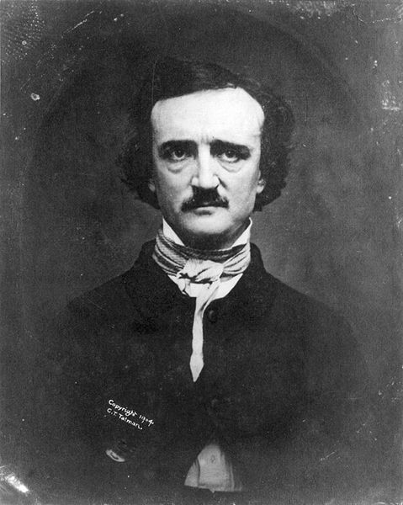 |  |  | Username: |  |  | Status goes here |  |  | 5 minutes ago
 |  |  | Wall |  | Info | Photos | +
 |  |  |  | What’s on your mind?
View photos of me (34)
Caption for photo or some informational text about the character

Information
Relationship Status:
Current City:
Birthday:
Friends

